THE COMBINED CONGREGATIONS

OF

**KNOX PRESBYTERIAN**

AND

**DURHAM ST METHODIST CHURCH**

****

**ORDER OF SERVICE**

Sunday 29th November 2015

ADVENT 1

A COMMUNION SERVICE

Music printed in this order of service is covered

under a music copyright licence agreement: LicenSing #604802

|  |
| --- |
| **WELCOME TO KNOX**  Knox Church is a congregation within the Presbyterian Church of Aotearoa New Zealand. We aim to create Christian community in which people of all ages, sexual orientations, cultural backgrounds and socio-economic situations are included as equally valued participants in our congregational life. We cherish our diversity, offering a safe place of belonging to any who wish to explore their beliefs in an atmosphere promoting discussion, the development of healthy relationships and spiritual growth. We strive to be open to dialogue and shared experiences with people of other faiths. We enjoy worshipping the God made known in Jesus, endeavouring to do so in ways that are relevant to our daily lives, respect the integrity of creation, and make a positive difference to our wider world. |

A loop system for hearing aids operates at Knox.

Toilets are available through the door on the lectern side of the sanctuary.

This is a communion service. On the understanding that God desires to nurture people at every stage of their journey, the table at Knox is an open one. Members of any denomination, as well as any who are seeking God sincerely, are welcome to receive communion here.

**The Call to Worship:**

We light a candle in the name of Jesus Christ, the Light of the world.

**JESUS, IN WHOM WE SAW GOD’S FAITHFULNESS AND CARING;**

**JESUS, THROUGH WHOM THE PEOPLE FOUND HOPE;**

**JESUS, IN WHOSE NAME WE SING AND REJOICE.**

Kia noho a Ihowa ki a koutou. God be with you.

**MA IHOWA KOE E MANAAKI. GOD BLESS YOU.**

**Hymn:**

Veni Emmanuel from Fifteenth Century French Processional

|  |  |
| --- | --- |
| 1. O come, O come, Emmanuel,  and ransom captive Israel  that mourns in lonely exile here,  until the Christ of God appear.  *Rejoice! Rejoice!*  *Emmanuel shall come to you,*  *O Israel!* | 2. O come, O Wisdom from on high,  and order all things far and nigh,  to us the path of knowledge show,  and help us in that way to go.  *Rejoice . . .* |

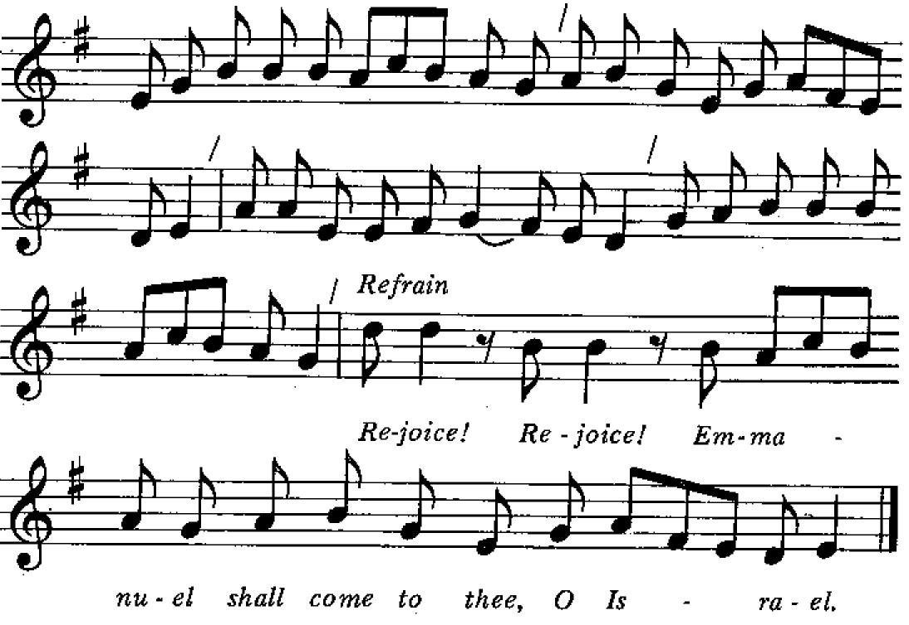

|  |  |
| --- | --- |
| 3. O come, O Day-spring, come and cheer  our spirits by your advent here;  love stir within the womb of night,  and death’s own shadows put to flight.  *Rejoice . . .* | 4. O come, Desire of Nations, bind  all peoples in one heart and mind;  make envy, strife and quarrels cease;  fill the whole world with heaven’s peace.  *Rejoice . . .* |

*Based on antiphons from Advent Vespers,*

*trans. John Mason Neale (1818-1866) and others, alt.*

**Prayer of Approach**

Emmanuel, God with us,

God living within who we are

and how we deal with one another,

God being the lively force

within our better awakening,

**WE REJOICE IN WHO YOU ARE.**

Emmanuel, God with us,

hope for those who have been exiled,

liberty for those who are chained

by this world’s many colourful captors,

you now come near.

**WE REJOICE IN YOUR CLOSENESS AND REALITY**.

Emmanuel, God with us,

Wisdom whom we need,

Opener of the paths that need to be trod;

through our world’s deep and enduring confusion,

you give enlightenment and the most loving way forward.

**WE REJOICE IN THE MINDS YOU OPEN.**

Emmanuel, God with us,

slowly working, surely, to make peace,

you form one loving unity

from warring nations.

**WE REJOICE IN YOUR MENDING MINISTRY.**

Beyond the litany of rejoicing, O God,

we confess the missiles,

the misapprehended statements,

the bombings and hostage takings,

the ”nowhere is safe” travel advisories

and the fear.

And we say:

. . . Lord have mercy.

**CHRIST HAVE MERCY.**

Lord have mercy.

**Assurance and Response**

. . . In the name of Christ I say to you:

You are forgiven and you are free.

**THANKS BE TO GOD.**

**AMEN.**

**The Notices**

|  |
| --- |
| *If there are younger ones present*  **A Conversation with the Younger Ones**  **The Advent Wreath – the candle of hope**    We light a candle for hope.  **BLESS US, O GOD, TO BE PEOPLE OF HOPE**.  That hope might shine like a light in the darkness,  **COME, JESUS CHRIST.**  **Young People’s Blessing:**  Young ones, go to your worship with our blessing.  **TAKE OUR FAITH AND HOPE;**  **MAKE NEW THINGS WITH WHAT YOU HAVE BEEN GIVEN.**  **MAY GOD BLESS AND GROW YOU.**  **AMEN.** |

*Young ones are welcome to move through to the Sala del Sol (upstairs in the Knox Centre) for well supervised, faith-based youth activities.*

**Scripture Lesson:** Jeremiah 33: 14-16

In this is the Word of God.

**THANKS BE TO GOD.**

**Combined Choir:** The Lord will soon appear

J.S. Bach (1685-1750)

**Sermon**

**Prayers for Others and Ourselves**

**. . . OUR FATHER IN HEAVEN**

**HALLOWED BE YOUR NAME,**

**YOUR KINGDOM COME, YOUR WILL BE DONE,**

**ON EARTH AS IN HEAVEN.**

**GIVE US TODAY OUR DAILY BREAD.**

**FORGIVE US OUR SINS**

**AS WE FORGIVE THOSE WHO SIN AGAINST US.**

**SAVE US FROM THE TIME OF TRIAL**

**AND DELIVER US FROM EVIL.**

**FOR THE KINGDOM, THE POWER AND THE GLORY ARE YOURS**

**NOW AND FOR EVER. AMEN.**

**The Offering and Dedication**

*We stand for the dedication of the Offering.*

Blessed are you, O God of all creation.

Through your goodness, we have this money to offer,

which we have earned

using the talents that you have given us.

It will further the work of your kingdom.

**BLESSED BE GOD FOREVER.**

Blessed are you, O God of all creation.

Through your goodness we have this bread to offer,

which earth has given and human hands have made.

It will become for us the bread of life.

**BLESSED BE GOD FOREVER.**

Blessed are you, O God of all creation.

Through your goodness we have this wine to offer,

fruit of the vine and work of human hands.

It will become for us our spiritual drink.

**BLESSED BE GOD FOREVER,**

**THROUGH JESUS CHRIST OUR LORD, AMEN.**

**The Passing of the Peace**

Kia tau tonu te rangimarie o te Ariki ki a koutou.

The peace of Christ be with you all.

**A KI A KOE ANO HOKI;**

**AND ALSO WITH YOU.**

*We exchange a sign of peace with one another.*

**Communion Hymn**:

Stuttgart Melody attrib. Christian F. Witt (1660-1716)

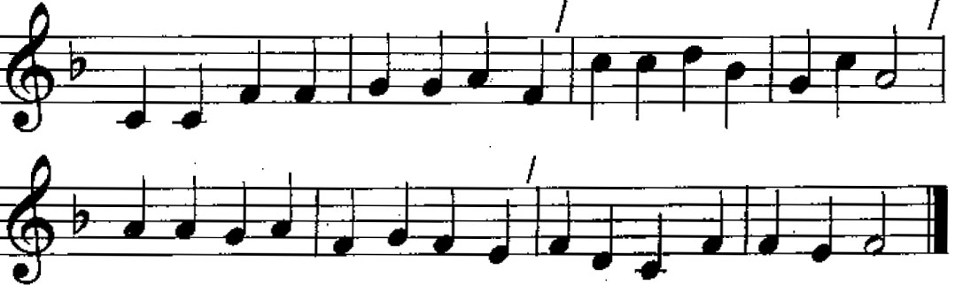

1. Come, O long-expected Jesus,

born to set all people free;

from our fears and sins release us,

grant us your true liberty.

2. Israel's strength and consolation,

hope to all the earth impart;

dear desire of every nation,

enter every longing heart.

3. Born all people to deliver,

born a child, you came to reign!

Born to rule on earth for ever,

come, be known to us again.

4. By your own eternal Spirit

come to claim us as your own;

by your all-sufficient merit

let us share your cross and crown.

*Charles Wesley (1707-1788)*

*We sit for*

**The Invitation**

**The Institution**

**The Setting Apart of the Elements**

**The Great Eucharistic Prayer**:

May God be with you.

**AND ALSO WITH YOU.**

Lift up your hearts.

**WE LIFT THEM TO GOD.**

Let us give thanks to the world’s creator.

**IT IS RIGHT TO GIVE OUR THANKS AND PRAISE.**

It is right indeed . . .

**The Breaking of the Bread**

**Lamb of God**:

Jesus, Lamb of God,

**HAVE MERCY ON US.**

**JESUS, BEARER OF OUR SINS,**

**HAVE MERCY ON US.**

**JESUS, REDEEMER OF THE WORLD,**

**GRANT US YOUR PEACE.**

**The Communion**

*For the distribution, please come forward to the table, take some bread from the loaf, dip it in the cup, and return to your seat. If you prefer non-alcoholic grape juice or gluten free bread, please take communion from the server with the communion tray.*

**The Prayer After Communion**

Eternal God,

we give you thanks and praise

that while we were still far off

you met us in your Son, and brought us home.

**MAY WE WHO SHARE HIS BREAD**

**LIVE HIS RISEN LIFE;**

**WE WHO DRINK HIS CUP**

**BRING LIFE TO OTHERS;**

**WE WHOM THE SPIRIT LIGHTS**

**GIVE LIGHT TO THE WORLD,**

**THAT ALL YOUR CHILDREN SHALL BE FREE,**

**AND THE WHOLE EARTH LIVE TO PRAISE YOUR NAME.**

**AMEN.**

**Hymn:**

Praise my soul John Goss (1800-1880)

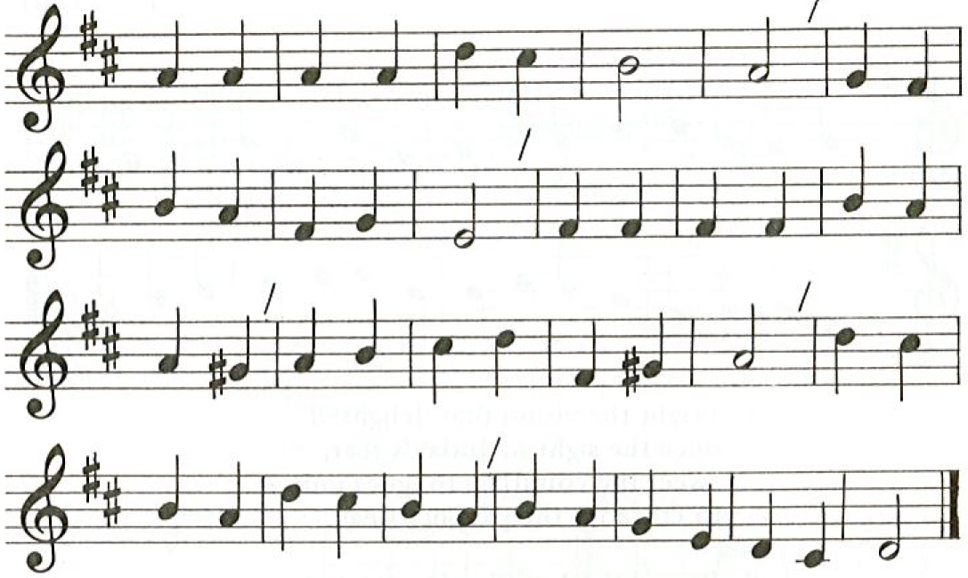

1. Praise with joy the world’s Creator,  
God of justice, love and peace,  
Source and end of human knowledge,  
Force of greatness without cease.  
Celebrate the Maker’s glory -  
Power to rescue and release.

2. Praise the Son who feeds the hungry,  
Frees the captive, finds the lost,  
Heals the sick, upsets religion,  
Fearless both of state and cost.  
Celebrate Christ’s constant presence -  
Friend and Stranger, Guest and Host.

3. Praise the Spirit sent among us,  
Liberating truth from pride,  
Forging bonds where race or gender,  
Age or nation dare divide.  
Celebrate the Spirit’s treasure -  
Foolishness none dare deride.

4. Praise the Maker, Son and Spirit,  
One God in community,  
Calling Christians to embody  
Oneness and diversity.  
Thus the world shall yet believe, when  
Shown Christ’s vibrant unity.

*The Iona Community*

**Benediction** and **Sung Amen**

**Postlude**

Tea and coffee are served in the Knox Centre Lounge following the morning service

|  |  |
| --- | --- |
| **Macintosh HD:Users:matthew:Desktop:mattart.jpg** | **Bible readings for next week**  The readings for next week’s service are likely to be:   * Malachi 3: 1-4 * Luke 1: 68-79 |

|  |  |  |
| --- | --- | --- |
| **Knox Directory**   |  |  | | --- | --- | | 28 Bealey Ave, Christchurch 8013  ph. (03) 379 2456,  fax (03) 379 2466  office@knoxchurch.co.nz  Office hours: Mon-Fri 9.00am-noon  Secretary: Diane Harrington,  ph. (03) 379 2456  Visit our website  www.knoxchurch.co.nz | Minister: Rev. Dr Matthew Jack  ph. (03) 3570 111, [minister@knoxchurch.co.nz](mailto:minister@knoxchurch.co.nz)  Session Clerk: Janet Wilson,  ph. (03) 338 7203  Director of Music: Daniel Cooper,  [organist@knoxchurch.co.nz](mailto:organist@knoxchurch.co.nz)  Pastoral Assistant: Jan Harland  ph. 0273560215 | |

- - - - - - - - - - - - - - - - - - - - - - - - - -

|  |
| --- |
| **Keeping in Touch**  Please help us get acquainted with you by filling in this form  and putting it in the offering bag.  Name:  Contact details |

**MacHD:private:var:folders:jd:88fw6f2x36x1k5y0r49_8v1h0000gn:T:TemporaryItems:cws-logo.gif**

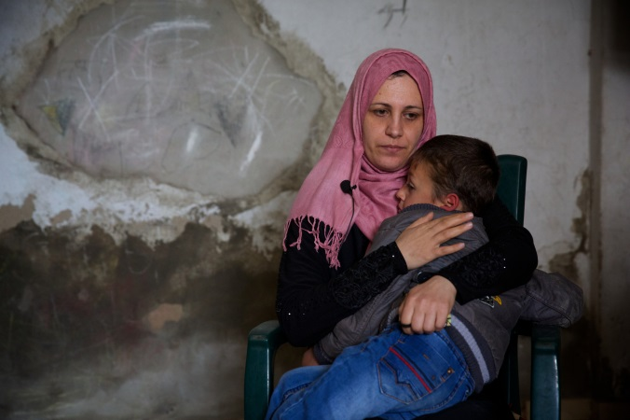**Christian World Service Christmas Appeal:**

**“Week by Week” partners**

**Restoring Hope for Gaza’s Traumatised Children**

Last year’s war in Gaza left Tarek deeply troubled. Months went by, and his family became more concerned. Hiding behind a smile, he could only talk about the damage to the family home – cracks in the walls and the kitchen ceiling that had collapsed. Otherwise he was silent. If anyone tried to touch him, he pushed them away.

Finally his worried mother took him to the local medical clinic run by DSPR Gaza (Department of Service to Palestinian Refugees) for help. At the clinic the pair were warmly greeted and joined others waiting for assessment. Diagnosed with Post-Traumatic Stress Disorder, Tarek began treatment with Budour, the clinic’s psychologist. After the second session, she said he was calmer and could sit on a chair. “God willing, I believe he will get better,” she said.

At last five year old Tarek is beginning to draw happy pictures. He has learnt skills to deal with the anxiety and fear that took over his life. Your gifts have helped Budour and the trained medical staff in DSPR Gaza’s three clinics to be a lifeline to their communities.

While over 3,500 children were injured in the war, it is the psychological suffering that is perhaps the hardest to deal with in a land where violence is common. One study [said](http://www.theguardian.com/world/2015/jul/06/gaza-grieves-casualties-palestinians-israeli-offensive) nine out of ten children report regularly feeling afraid. Bedwetting, night terrors and anxiety are common. Without specialist help, children invent their own reasons for the bombing and feelings of insecurity that may escalate their uncertainty and fear. Like the rest of Gaza’s residents they worry about the next war.

Shija’ia, the neighbourhood in which Tarek’s family lives, was heavily bombed in the 51 day war. The medical clinic was damaged as were surrounding streets. Volunteers made hasty repairs so the clinic could reopen during the 24 hour ceasefires. Staff and volunteers despite their own hardships were determined to help the mothers and children who they knew needed care. Medical services were offered free to large numbers of people suffering from upper respiratory infections, gastroenteritis, diarrhoea, vomiting and skin diseases caused by the lack of water and sanitation.

**Department of Service to Palestinian Refugees**

DSPR grew out of work begun in 1948 to support Palestinians forced to flee their homes in the newly created state of Israel. Part of the Middle East Council of Churches, it has worked tirelessly to provide practical assistance to the refugees. Integral to their work is advocacy for Palestinians and work towards a just peace. One of their fundamental concerns is the right of return for refugees. They are part of [Kairos Palestine](http://www.kairospalestine.ps/), a Christian call to creative resistance to end the Israeli occupation and seek justice for Palestinian people. CWS began funding their work with gifts from the 1949 Christmas Appeal, making it our oldest partner.

DSPR:

* Runs three primary health clinics for mothers and children in poor and overpopulated areas of Gaza (Shija’ia, Darraj and Rafah), and one each in Jordan’s Madaba and Jerash camps for Syrian and Palestinian refugees (for a population of over 100,000 people) and dental clinics as well as health education programmes. The Rafah clinic serves a remote population where medical services are practically non-existent.
* Offers trauma counselling and psychological support programmes in Gaza – last year helping more than 10,000 individuals.
* Improves water transmission systems, wells and rainwater cisterns including on the West Bank where Israel controls 85% of water resources. The water programme includes advocacy work to change Israeli policies and practices and to support affected communities in pursuing their water rights.
* Provides vocational training programmes for Palestinian young people and recreational activities in Gaza, Jordan, and Lebanon. In Gaza it offers five programmes: secretarial studies with English language, advanced dressmaking, and general electrical skill training as well as carpentry and furniture making, and metal and aluminium training for disadvantaged boys aged 14-16 years.
* Runs a nursery and kindergarten in Lebanon as well as after school tutoring, English course, literacy classes, art and music classes, sports opportunities and summer camps in Lebanon.
* Provides interest free loans for university and college fees as well as business and housing loans.
* Provides agricultural training and helps families establish gardens and food selling businesses, with a particular focus on vulnerable families living close to the separation barrier and illegally built Israeli settlements in the Northwest of the West Bank.
* Runs training programmes in human rights, on gender issues, youth and children’s empowerment, youth leadership and interfaith understanding.
* Provides essential emergency food and non-food supplies to families needing help in Gaza and seeking refuge from Syria. [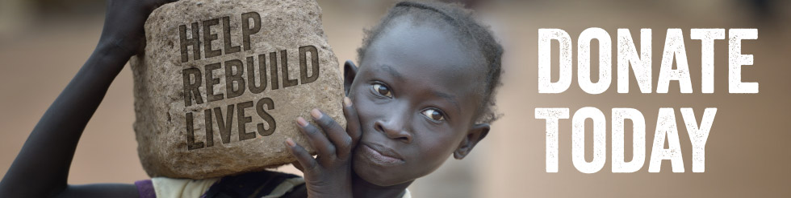](http://christmasappeal.org.nz/donate/)